Skills for Successful Negotiating  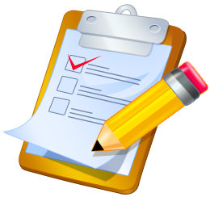  These are some of the skills needed for successful negotiating. If participants do not mention any of these, add them to the list yourself.  Negotiation Skills  - Effective speaking  - Effective listening  - A sense of humor  - A positive attitude  - Respect  - Self-confidence  - Emotional intelligence  - Persistence  - Patience  - Creativity | Establishing Your WATNA and BATNA    In most negotiations, the parties are influenced by their assumptions about what they think are the alternatives to a negotiated agreement. Often the parties have an unrealistic idea of what these alternatives are, and they are unwilling to make concessions because they think they can do just as well without negotiating. If you do not have a clear idea of your WATNA (Worst Alternative to a Negotiated Agreement) and BATNA (Best Alternative to a Negotiated Agreement), you will negotiate poorly based on false notions about what you can expect without an agreement.
Personal Preparation
One way to relieve some of the tension you may be feeling before a negotiation is to remind yourself that there is nothing to be afraid of. As long as you understand your position, there is no danger that you will “lose” the negotiation. During and before negotiation you should always be:

- Polite - It never reduces your argument
- Firm - Removes Perceptions of Weakness

- Calm - Facilitates Persuasion and Compromise
- Do not take things personally
Knowing your position before entering negotiations means that you are sure of your “red lines”. Things that you are not prepared to consider that would make your position worse than it is now. Many people get pushed into a deal which is unsatisfactory to them because they have failed to prepare for the negotiation in this way. If you go into negotiations with vague ideas, that vagueness will become a weakness in your negotiating position.

